Information Technology Building 1F Square Management Regulations
103(Republic Era)/6/5 Computer Center Management Conference Passed
1. NCKU Computer Center (Our center) legislated these regulations according to the “國立成功大學集會場所管理辦法”(NCKU Public Space Management Regulations) for the effective management of the Information Technology Building 1F Square (The square).
2. One should fill out the application form to get the permission to use the square beforehand. The application form should be completed and sent to the information desk on the 2F of the computer center from 2 months to 1 week prior to date of the planned event.
3. One should maintain moderate volume when using the square to avoid bothering and affecting the surrounding educational and administration facilities, one should also not blocking or affecting the personnel access of our center (The available area of the square is shown in the image below). If one still does not follow the rules after being reported, our center has the rights to terminate the rental terms and ask the personnels to leave the square immediately.
4. Our center does not provide electricity for non-authorized use. Please do not use any electrical outlets without authorization.
5. For maintaining clean environment, please do not dine at the square. When the event is over, the applicant(s) should clean up all the garbages and revert the square to the the original state.
6. If one violate the third and the fifth regulations, our center will refuse any rental application from the applicant/organization afterwards. Our center will ask the responsible organization to punish the personnels who break the regulations
7. Our center only provides the rental service of the facility, the applicant should be responsible for the order of the event and the safety of the attending personnels.
8. These regulations are appropved by the management committee.

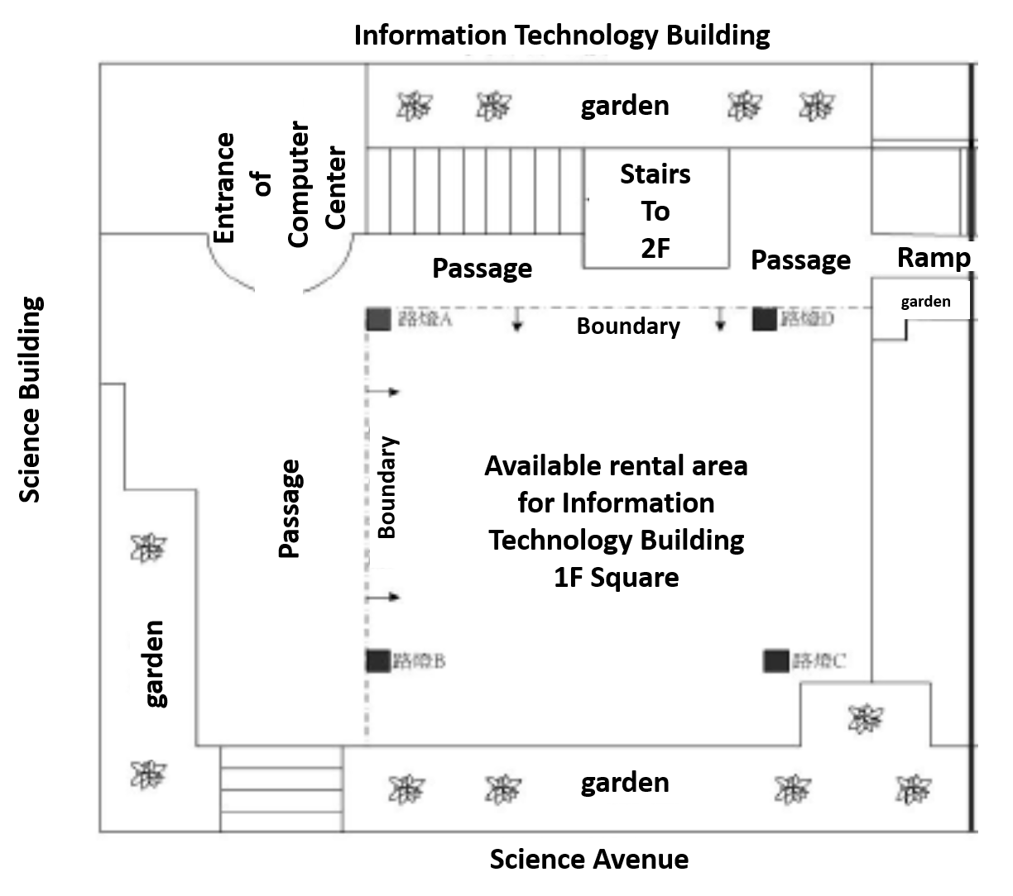

NCKU Computer Center
Information Technology Building 1F Square Rental Application Form
》Please read “國立成功大學資訊大樓一樓廣場管理要點” (Information Technology Building 1F Square Rental Application Form (Regulations included)) carefully before applying.
》 The application form should be sent to the information desk on 2F of our center from 2 months to 1 week prior to the date of the planned event. For more information, please call 06-2757575 # 61021
Application organization: |  | Application date:
Applicant | Name：  (Signature or Seal) | Phone number：
 | Class or job title： | E-mail：
Event content | （Please follow the seventh regulation of “NCKU Public Space Management Regulations” to attach the event plan） |  |  | Participants:  about____people
Rental Period | Single day:  ______(date) _____(day, ex: Friday)  Time: from________ to __________
Multiple days:
From ______(date) _____(day)__
To _______(date) _____(day)_ Time: from_____to______ Comments:
Organization manager or advisor:  (Signature or seal) |  |  | Organization seal
Verification of Computer Center:
□ Agree
□ Disagree Reason:

Case handler: Leader: Director:

